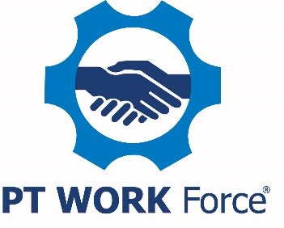

Sample Job Posting Template

Job Title: Benefits Administrator

About Us [or What Makes Our Company Special]
Include all the cool things about your company and what makes your firm special. As an example:

PTDA Bearings & Power Transmission, Inc. is a small family business that believes our employees are part of the family and our company is part of the community. From our central location for the past 84 years, you may have seen us pitch in at the local food bank, sponsor a Little League team and hold a holiday open house for the community.

Our Values
Explain how the position fits in the company and why it is important. As an example:

Our mission is to keep our customers, our suppliers and our employees saying good things about how they were treated.

Explain why this position is important to your company:

The benefits administrator develops and manages employee benefits programs, including being the main point of contact for employees’ questions on our benefit programs. This position oversees the benefit enrollment process and assures that all forms are properly filled out and returned by the due-date so coverage is in place. Benefits are very important to our employees and this individual is the company’s go-to person for problem resolution and explanation of specific programs.

The Job
List three-five tasks the person is responsible for. Use an active voice.

The benefits administrator is the person employees will come to when they need to understand and/or enroll in one of our programs. The benefits administrator needs to develop a thorough understanding of all benefit programs and be able to explain to all levels of employee. This individual must be approachable, exhibit empathy and sincerely want to assist employees.

- Administers all employee benefit programs including group health, flexible spending accident, disability and life insurance.
- Serves as the primary contact for vendors of all benefit programs.
- Prepares and distributes all benefit plan materials to employees.

The Ideal Candidate
Describe the kind of person who would be a perfect fit for the job.

The ideal candidate for this critical position has prior experience establishing and monitoring employee benefit programs. They must be able to answer all questions regarding the company’s benefit program and provide guidance to managers on employee issues related to benefits and leaves. The ideal candidate will be people-oriented, a good communicator, possess empathy, and be able to relate to all employees. They must be able to facilitate the requirements of the position while establishing a congruent and positive environment and experience, with the employee, both in a one-on-one and/or through a virtual communication platform such as Microsoft Teams.

Our Offer
What’s in it for them (besides the job)? For this level of position, benefits such as retirement planning, paid health insurance and paid time off as well as a flexible work schedule are important. Remember to include benefits, especially any that you believe are unique to your company. Potential candidates are interested in salary/pay rate. You may want to consider including to help weed out those not willing to work for what you’re offering.

We offer a competitive salary and benefits package and provide 15 paid days off a year at this level. We also provide health and dental insurance for you and your dependents as well as a 401(k) with employer match up to four percent. This position is eligible for a hybrid remote/in-person work arrangement.

Include any other additional information that would help a candidate learn more about your company. As an example:

To learn more about us, watch our video at youtube.com/PTDABearings.

Close with letting the candidates know how to communicate with you. It is essential that you offer an electronic way for them to apply.

Let us know you’re interested! Click on the link below to apply or email your resume to HR@PTDABearings.com.

